E3_q1

SQL query is similar to the following: --#SET TERMINATOR @ CREATE OR REPLACE PROCEDURE UPDATE_LEADERS_SCORE (IN in_School_ID INTEGER, IN in_Leader_Score INTEGER) LANGUAGE SQL BEGIN END@

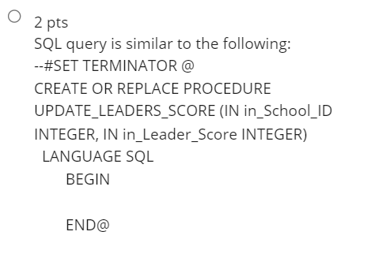

E3_q2

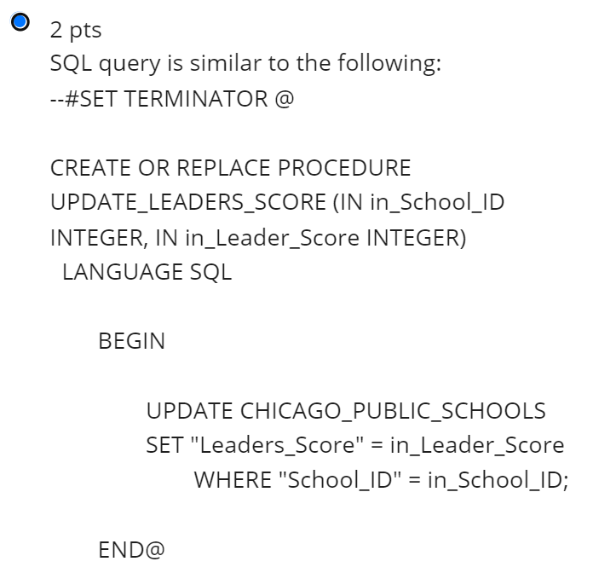

SQL query is similar to the following: --#SET TERMINATOR @ CREATE OR REPLACE PROCEDURE UPDATE_LEADERS_SCORE (IN in_School_ID INTEGER, IN in_Leader_Score INTEGER) LANGUAGE SQL BEGIN UPDATE CHICAGO_PUBLIC_SCHOOLS SET "Leaders_Score" = in_Leader_Score WHERE "School_ID" = in_School_ID; END@

E3_q3

SQL query is similar to the following: CREATE OR REPLACE PROCEDURE UPDATE_LEADERS_SCORE (IN in_School_ID INTEGER, IN in_Leader_Score INTEGER) LANGUAGE SQL BEGIN UPDATE CHICAGO_PUBLIC_SCHOOLS SET "Leaders_Score" = in_Leader_Score WHERE "School_ID" = in_School_ID; IF in_Leader_Score > 0 AND in_Leader_Score < 20 THEN UPDATE CHICAGO_PUBLIC_SCHOOLS SET "Leaders_Icon" = 'Very Weak'; ELSEIF in_Leader_Score < 40 THEN UPDATE CHICAGO_PUBLIC_SCHOOLS SET "Leaders_Icon" = 'Weak'; ELSEIF in_Leader_Score < 60 THEN UPDATE CHICAGO_PUBLIC_SCHOOLS SET "Leaders_Icon" = 'Average'; ELSEIF in_Leader_Score < 80 THEN UPDATE CHICAGO_PUBLIC_SCHOOLS SET "Leaders_Icon" = 'Strong'; ELSEIF in_Leader_Score < 100 THEN UPDATE CHICAGO_PUBLIC_SCHOOLS SET "Leaders_Icon" = 'Very Strong'; END IF; END@

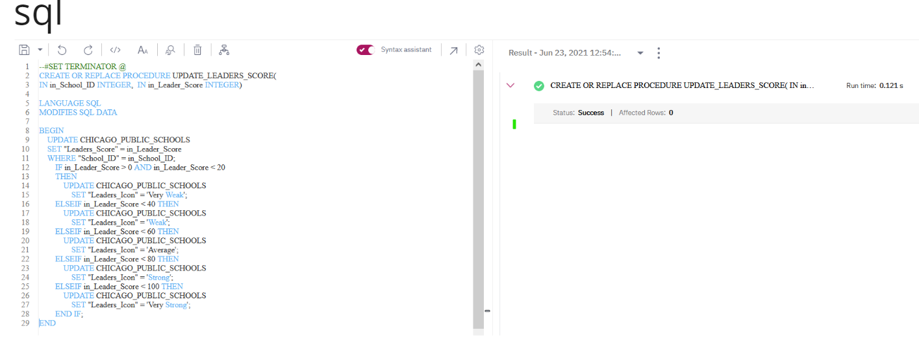

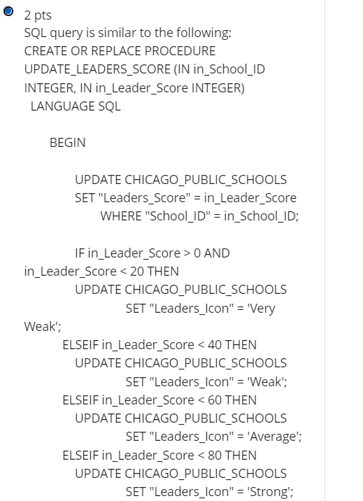

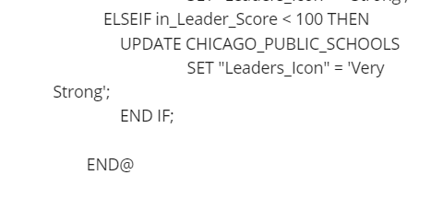

Q3_4:

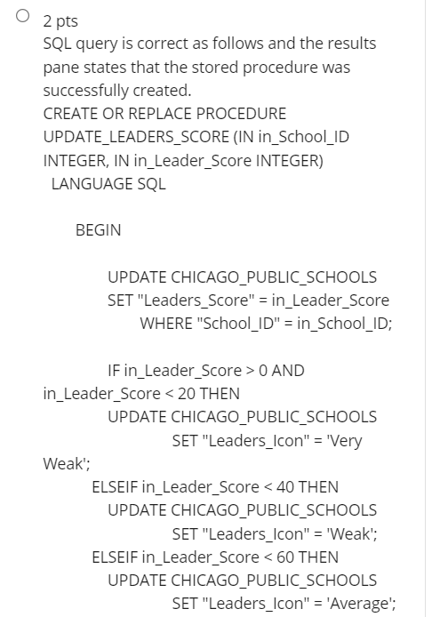

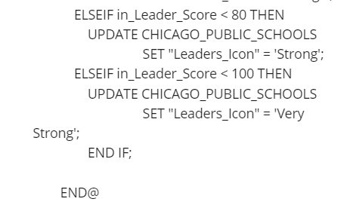

**E4_q1:**

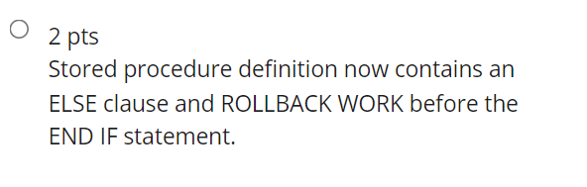

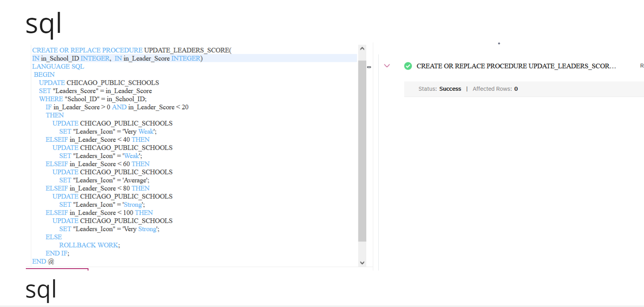

E4_q2

